Title in Times New Roman 13-point, bold, centered (NOT in ALL CAPITAL letters), official language: English
{enter (12p)}
Presenting Author¹, Name Surname¹, Name Surname², … (add Name and Surname for all authors, NO Abbreviations of Names) (centered, 11p)
e-mail: email@address.it (centered, italics - 10p)
{enter (9p)}
¹ Dept, Institute, Address, ZIP/CAP-City, Country (centered, italics - 10p)
² Dept, Institute, Address, ZIP/CAP-City, Country (centered, italics - 10p)
{enter (12p)}
Please type the body of the abstract text here (including references cited in the text as [1], before the punctuation mark and between square brackets [2]), tables cited as Table 1 and figures/schemes cited as Figure 1/Scheme 1) line spacing: 1.15 in 11-point Times New Roman. Figure/Table captions must follow the text rules (Times New Roman 11p, figures and schemes only png/jpg/tif min 600dpi), please look at the example below.
Please make a 1.0 cm indentation when starting a new line. Text should be justified on a page. References must be detailed at the bottom of the page as shown below. Please respect rigorously these formatting rules for references: Times New Roman (10p), justified.
The abstract cannot exceed ONE PAGE (A4) of text, references, tables and figures.
PLEASE DO NOT MODIFY font size (11p), line spacing (1.15) and margins (top: 2.0cm, down: 1.5cm, left: 2.0cm, right: 1.5cm)!!! These instructions are an example of what a properly prepared meeting abstract should look like. Authors are requested to strictly follow all of the requirements as here proposed.
Please send the abstract to ecnp2023@info.p.lodz.pl as a WORD document (ONLY “.doc” or “.docx” format allowed, NO “.pdf”), please name your abstract: Surname_Name.doc(x).
{enter before Figure/Scheme/Table (10p)}
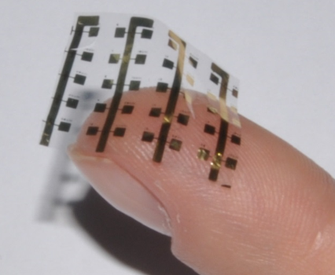
Figure 1: Caption here (no additional space between figure/scheme/table and description)
{enter before acknowledgements (10p)}
Acknowledgements, grant financing, etc. Times New Roman (10p), centered, italics
{enter before references (10p)}
[1] K. Binder, M. Müller, J. Baschnagel, Polymer models on the lattice, [in:] M. Kotelyanskii, D. N. Theodorou (eds.) Simulation methods for polymers, Marcel Dekker, New York-Basel 2004, 125-146.
[2] L. Monico, K. Janssens, E. Hendriks, F. Vanmeert, M. Cotte, G. Falkenberg, B. G. Brunetti, C. Milani, Angewandte Chemie International Edition, 2015, 54, 13293-13297.

